# **Schema HomePro**

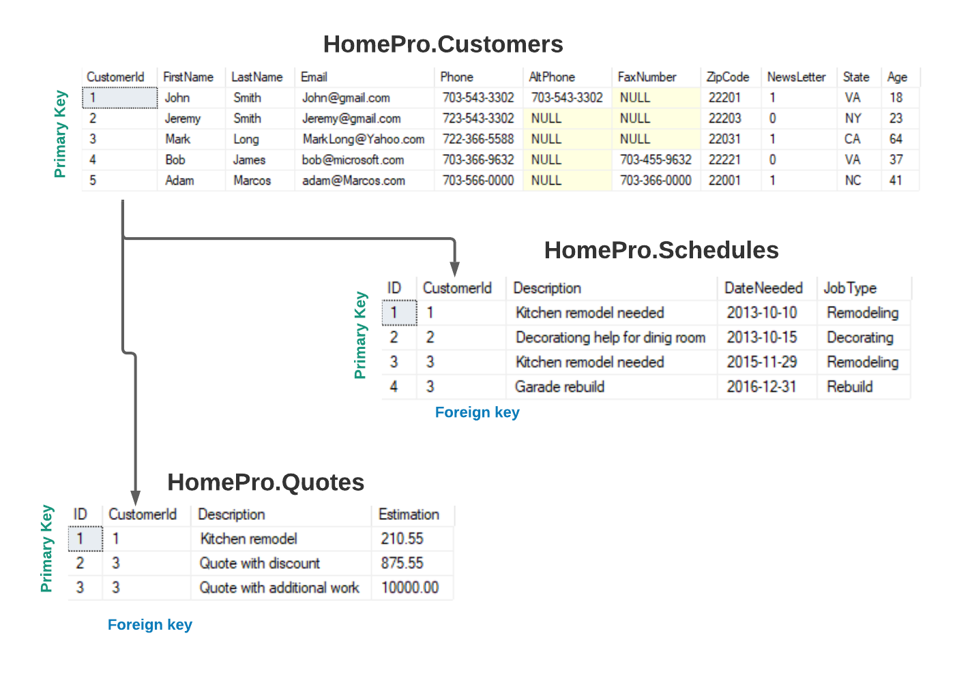

## **SQL Query tasks (DML)**

A data manipulation language (DML) is a standard for commands that allow users to manipulate data in a database. This manipulation involves inserting data into database tables, retrieving existing data, deleting data from existing tables and modifying existing data. DML is mostly incorporated in SQL databases.

### Homepro.Customers

1. Get all a data from Table Customers
2. Find all Customers with LastName = ’Smith’
3. Find all Customers that have the letter ‘m’ in LastName
4. Get the **FirstName, LastName, State, Age** for customers who has the letter ‘m’ in LastName and older than 30.
5. Get the **FirstName,LastName,Phone, Zipcode** for all clients with ZipCode ‘22201’.
6. Get the **FirstName,LastName,Phone,Email,FaxNumber** of all clients who does not have FaxNumber.
7. Get all data of client whose FirstName starts from letter ‘M’
8. Get Names and phones of all clients subscribed on NewsLetter
9. Get information about clients who’s Phone contains ‘703’.
10. Get information about clients whose ZipCode between ‘22200’ and ‘22300’.

### Homepro.Schedules

1. Find all schedules scheduled after ‘2016-01-01’.
2. Find all schedules scheduled within a year 2013.
3. Show all rows with JobType ‘Remodeling’.
4. Show all rows where Description contains word ‘kitchen’.

### Homepro.Quotes

1. Find all Quotes for ‘Kitchen’.
2. Find all Quotes bigger than $500.
3. Find Quotes where Description contains word ‘discount’.

Send your homework to email [Andrew.a4100@gmail.com](mailto:Andrew.a4100@gmail.com) for validation